长摘要要求
内容要求
包括标题、作者姓名及单位、长摘要正文（背景、目标和内容、研究方法、结果与讨论、结论）、关键词、主要图表及参考文献。长摘要正文800-1000字（不含参考文献字数）。只提交全英文长摘要。
格式要求
英文题名:
Times New Roman，小三，加粗，两端对齐，段前1行，段后0行，仅第一个单词和专有名词首字母大写，如题目中有冒号，则冒号后第一个单词首字母也需大写。
英文作者名：Times New Roman，小四。
英文地址：Times New Roman，小五。
英文摘要及关键词：
Times New Roman，五号。“Background, Aims and Scope.”，“Methods.”，“Results and Discussion.”，“Conclusion.”，“Keywords”加粗。其中关键词须设置段前0行，段后1行。
图表：
英文图题表题为Times New Roman，小五，加粗。图表中所有字母、文字字号大小应一致（一般用小五号）。
图表随正文，先见文字后见图表；图题位于图后，表题位于表前。
表格使用三线表，直接放在正文中适当的位置。表格应配有表序号、表题和详尽的表文、表注，使表格具有自明性。表格按照在正文中提到的先后顺序排序并用阿拉伯数字标注序号。表序号与表题在表格上方，表注在表格下方。在量符号（斜体）与单位（正体）之间用斜线隔开， 例如：时间及其单位写为：“t/min”，其中t为斜体，min为正体；浓度及其单位为：c/mg·L⁻¹其中c为斜体，mg·L⁻¹为正体。
参考文献：
参考文献的写法应遵循国际上的通用习惯，且应全文统一，不能混用。在摘要正文中引用了参考文献的位置，须用上标标注[参考文献序号]。
具体参考示例（注：该示例非真实发表论文）
命名要求
按照[姓名+学校]的格式命名稿件。
Abstract Requirements
Contents
Abstracts should be composed of the following parts: title, author name(s) and affiliation, main text of abstract (research background, aims and scope, research methods, results and discussion, conclusion), keywords, figures and tables, and references. The main text of the abstract should contain 800-1000 words. References are excluded from the word count. Abstracts should be written in English.
Format
Title in English:
Times New Roman,15 point, bold, align both ends, 1 line before segment, 0 line after segment
Author name(s) in English: Times New Roman, 12 point.
Address in English: Times New Roman, 9 point.
Abstract and keywords:
Times New Roman, 10.5 point. “Background, Aims and Scope”, “Methods”, “Results and Discussion”, “Conclusion”, and “Keywords” should be bold. For keywords: 0 line before segment, 1 line after segment.
Figures and tables
Title of figures and tables: Times New Roman, 9 point, bold. Font size of all letters and words in the figures and tables should be the same (usually in 9 point).
Tables and figures should be mentioned in the text before they appear in the document. Captions for tables are placed above the table, and captions for figures are placed below the figure.
Tables use three-line tables and are placed directly in the text at the appropriate location. Tables should be accompanied by a table number, a table title, and detailed table text and table notes to make the table self-explanatory. Tables are sorted in the order in which they are mentioned in the text and marked with Arabic numerals. The table serial number and table title are at the top of the table, and the table notes are at the bottom of the table. For example, time and its unit are written as "t/min", where t is in italics and min is in non-italics; concentration and its unit are: c/mg·L⁻¹, where c is in italics and mg·L⁻¹ is in non-italics.
References:
Reference citations should be accurate, complete, and presented in a consistent format. References should be numbered and ordered sequentially as they appear in the text, with reference numbers in superscript and enclosed in brackets.
Please refer to the template for details. (The template is only for demonstrative purposes).
File Naming
The extended abstract should be named in the format of [Author’s Name + School].

Research on permeability of municipal solid waste: A case study
Wang Zhigang¹, Chen Xiangdong², Zhuge Ying³, Li Ming^{1,*}
(1. Department of Thermal Engineering, Tsinghua University, Beijing 100084, China; 2. Institute of Solar Energy, Xi’an Jiaotong University, Xi’an 710049, China; 3. Department of Power & Energy Engineering, Shanghai Jiaotong University, Shanghai 200030, China)
*Email: liming@tsinghua.edu.cn

Background, Aims and Scope. Aim at the research of landfill is mainly in degradation and treatment of landfill leachate, but its permeability is not enough, starts with the influence factors, combined with physical tests in laboratory, the law of permeability of MSW was analyzed. Aim at the research of landfill is mainly in degradation and treatment of landfill leachate, but its permeability is not enough, starts with the influence factors, combined with physical tests in laboratory, the law of permeability of MSW was analyzed. Aim at the research of landfill is mainly in degradation and treatment of landfill leachate, but its permeability is not enough, starts with the influence factors, combined with physical tests in laboratory, the law of permeability of MSW was analyzed. Aim at the research of landfill is mainly in degradation and treatment of landfill leachate, but its permeability is not enough, starts with the influence factors, combined with physical tests in laboratory, the law of permeability of MSW was analyzed.
Methods. Aim at the research of landfill is mainly in degradation and treatment of landfill leachate, but its permeability is not enough, starts with the influence factors, combined with physical tests in laboratory, the law of permeability of MSW was analyzed. Aim at the research of landfill is mainly in degradation and treatment of landfill leachate, but its permeability is not enough, starts with the influence factors, combined with physical tests in laboratory, the law of permeability of MSW was analyzed. Aim at the research of landfill is mainly in degradation and treatment of landfill leachate, but its permeability is not enough, starts with the influence factors, combined with physical tests in laboratory, the law of permeability of MSW was analyzed.
Results and Discussion. Aim at the research of landfill is mainly in degradation and treatment of landfill leachate, but its permeability is not enough, starts with the influence factors, combined with physical tests in laboratory, the law of permeability of MSW was analyzed. Aim at the research of landfill is mainly in degradation and treatment of landfill leachate, but its permeability is not enough, starts with the influence factors, combined with physical tests in laboratory, the law of permeability of MSW was analyzed. Aim at the research of landfill is mainly in degradation and treatment of landfill leachate, but its permeability is not enough, starts with the influence factors, combined with physical tests in laboratory, the law of permeability of MSW was analyzed. Aim at the research of landfill is mainly in degradation and treatment of landfill leachate, but its permeability is not enough, starts with the influence factors, combined with physical tests in laboratory, the law of permeability of MSW was analyzed. Aim at the research of landfill is mainly in degradation and treatment of landfill leachate, but its permeability is not enough, starts with the influence factors, combined with physical tests in laboratory, the law of permeability of MSW was analyzed. Aim at the research of landfill is mainly in degradation and treatment of landfill leachate, but its permeability is not enough, starts with the influence factors, combined with physical tests in laboratory, the law of permeability of MSW was analyzed. Aim at the research of landfill is mainly in degradation and treatment of landfill leachate, but its permeability is not enough, starts with the influence factors, combined with physical tests in laboratory, the law of permeability of MSW was analyzed. Aim at the research of landfill is mainly in degradation and treatment of landfill leachate, but its permeability is not enough, starts with the influence factors, combined with physical tests in laboratory, the law of permeability of MSW was analyzed. Aim at the research of landfill is mainly in degradation and treatment of landfill leachate, but its permeability is not enough, starts with the influence factors, combined with physical tests in laboratory, the law of permeability of MSW was analyzed. Aim at the research of landfill is mainly in degradation and treatment of landfill leachate, but its permeability is not enough, starts with the influence factors, combined with physical tests in laboratory, the law of permeability of MSW was analyzed.
Conclusion. Aim at the research of landfill is mainly in degradation and treatment of landfill leachate, but its permeability is not enough, starts with the influence factors, combined with physical tests in laboratory, the law of permeability of MSW was analyzed. Aim at the research of landfill is mainly in degradation and treatment of landfill leachate, but its permeability is not enough, starts with the influence factors, combined with physical tests in laboratory, the law of permeability of MSW was analyzed. Aim at the research of landfill is mainly in degradation and treatment of landfill leachate, but its permeability is not enough, starts with the influence factors, combined with physical tests in laboratory, the law of permeability of MSW was analyzed.
Keywords: sludge; organic refuse; coal; co-combustion characteristic; kinetics
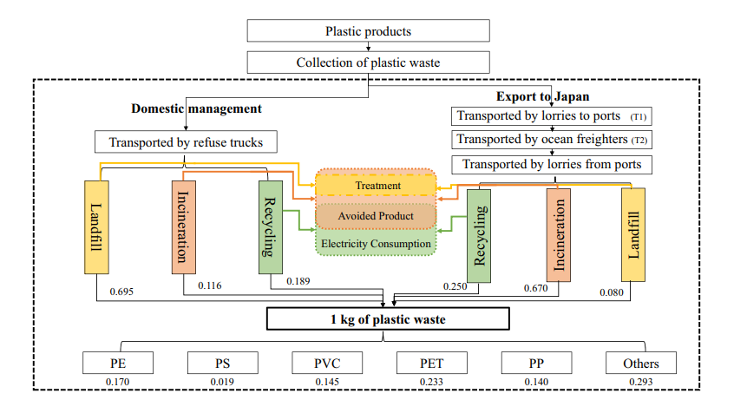
Fig. 1 System boundaries for LCA of EIT

Table 1 Proximate analysis and ultimate analysis of the tannery sludge
Industrial analysis (%) |  |  |  |  | Elemental analysis (%)
Moisture | Ash | Volatile matter | Fixed carbon | LHV  kJ/kg | C | H | N | S
73.25 | 13.11 | 13.61 | 0.03 | 5346.2 | 16.591 | 2.898 | 2.343 | 0.623
Elemental analysis of heavy metal (mg/kg) |  |  | Zn | Pb | Cd | Cu | Mn | Cr
 |  |  | 380 | 280 | 3 | 70 | 500 | 20490

References
[1] Zhang, S.; Li, S.; Zhou, W.; Zheng, L. Chem. Phys. 2011, 135: 14304.

