**Abstract Requirements**

**Contents**

Abstracts should be composed of the following parts: title, author name(s) and affiliation, main text of abstract (research background, aims and scope, research methods, results and discussion, conclusion), keywords, figures and tables, and references. The main text of the abstract should contain 800-1000 words. References are excluded from the word count. **Abstracts should be written in English.**

**Format**

**Title in English:**

Times New Roman,15 point, bold, align both ends, 1 line before segment, 0 line after segment

**Author name(s) in English:** Times New Roman, 12 point.

**Address in English:** Times New Roman, 9 point.

**Abstract and keywords:**

Times New Roman, 10.5 point. “Background, Aims and Scope”, “Methods”, “Results and Discussion”, “Conclusion”, and “Keywords” should be bold. For keywords: 0 line before segment, 1 line after segment.

**Figures and tables**

Title of figures and tables: Times New Roman, 9 point, bold. Font size of all letters and words in the figures and tables should be the same (usually in 9 point).

Tables and figures should be mentioned in the text before they appear in the document. Captions for tables are placed above the table, and captions for figures are placed below the figure.

Tables use three-line tables and are placed directly in the text at the appropriate location. Tables should be accompanied by a table number, a table title, and detailed table text and table notes to make the table self-explanatory. Tables are sorted in the order in which they are mentioned in the text and marked with Arabic numerals. The table serial number and table title are at the top of the table, and the table notes are at the bottom of the table. For example, time and its unit are written as "*t*/min", where *t* is in italics and min is in non-italics; concentration and its unit are: *c*/mg·L-1, where *c* is in italics and mg·L-1 is in non-italics.

**References:**

Reference citations should be accurate, complete, and presented in a consistent format. References should be numbered and ordered sequentially as they appear in the text, with reference numbers in superscript and enclosed in brackets.

Please refer to the template for details. (The template is only for demonstrative purposes).

**File Naming**

The extended abstract should be named in the format of [Author’s Name + School].

Research on permeability of municipal solid waste: A case study

Zhigang Wang1, Xiangdong Chen2, Ying Zhuge3, Julia Smith3, Ming Li1,*

(1. Department of Thermal Engineering, Tsinghua University, Beijing 100084, China; 2. Institute of Solar Energy, Xi’an Jiaotong University, Xi’an 710049, China; 3. Department of Power & Energy Engineering, Shanghai Jiaotong University, Shanghai 200030, China)

*Email: liming@tsinghua.edu.cn

**Background, Aims and Scope.** Aim at the research of landfill is mainly in degradation and treatment of landfill leachate, but its permeability is not enough, starts with the influence factors, combined with physical tests in laboratory, the law of permeability of MSW was analyzed[1]. Aim at the research of landfill is mainly in degradation and treatment of landfill leachate, but its permeability is not enough, starts with the influence factors, combined with physical tests in laboratory, the law of permeability of MSW was analyzed. Aim at the research of landfill is mainly in degradation and treatment of landfill leachate, but its permeability is not enough, starts with the influence factors, combined with physical tests in laboratory, the law of permeability of MSW was analyzed. Aim at the research of landfill is mainly in degradation and treatment of landfill leachate, but its permeability is not enough, starts with the influence factors, combined with physical tests in laboratory, the law of permeability of MSW was analyzed.

**Methods.** Aim at the research of landfill is mainly in degradation and treatment of landfill leachate, but its permeability is not enough, starts with the influence factors, combined with physical tests in laboratory, the law of permeability of MSW was analyzed. Aim at the research of landfill is mainly in degradation and treatment of landfill leachate, but its permeability is not enough, starts with the influence factors, combined with physical tests in laboratory, the law of permeability of MSW was analyzed. Aim at the research of landfill is mainly in degradation and treatment of landfill leachate, but its permeability is not enough, starts with the influence factors, combined with physical tests in laboratory, the law of permeability of MSW was analyzed.

**Results and Discussion.** Aim at the research of landfill is mainly in degradation and treatment of landfill leachate, but its permeability is not enough, starts with the influence factors, combined with physical tests in laboratory, the law of permeability of MSW was analyzed. Aim at the research of landfill is mainly in degradation and treatment of landfill leachate, but its permeability is not enough, starts with the influence factors, combined with physical tests in laboratory, the law of permeability of MSW was analyzed. Aim at the research of landfill is mainly in degradation and treatment of landfill leachate, but its permeability is not enough, starts with the influence factors, combined with physical tests in laboratory, the law of permeability of MSW was analyzed. Aim at the research of landfill is mainly in degradation and treatment of landfill leachate, but its permeability is not enough, starts with the influence factors, combined with physical tests in laboratory, the law of permeability of MSW was analyzed. Aim at the research of landfill is mainly in degradation and treatment of landfill leachate, but its permeability is not enough, starts with the influence factors, combined with physical tests in laboratory, the law of permeability of MSW was analyzed. Aim at the research of landfill is mainly in degradation and treatment of landfill leachate, but its permeability is not enough, starts with the influence factors, combined with physical tests in laboratory, the law of permeability of MSW was analyzed. Aim at the research of landfill is mainly in degradation and treatment of landfill leachate, but its permeability is not enough, starts with the influence factors, combined with physical tests in laboratory, the law of permeability of MSW was analyzed. Aim at the research of landfill is mainly in degradation and treatment of landfill leachate, but its permeability is not enough, starts with the influence factors, combined with physical tests in laboratory, the law of permeability of MSW was analyzed. Aim at the research of landfill is mainly in degradation and treatment of landfill leachate, but its permeability is not enough, starts with the influence factors, combined with physical tests in laboratory, the law of permeability of MSW was analyzed. Aim at the research of landfill is mainly in degradation and treatment of landfill leachate, but its permeability is not enough, starts with the influence factors, combined with physical tests in laboratory, the law of permeability of MSW was analyzed.

**Conclusion.** Aim at the research of landfill is mainly in degradation and treatment of landfill leachate, but its permeability is not enough, starts with the influence factors, combined with physical tests in laboratory, the law of permeability of MSW was analyzed. Aim at the research of landfill is mainly in degradation and treatment of landfill leachate, but its permeability is not enough, starts with the influence factors, combined with physical tests in laboratory, the law of permeability of MSW was analyzed. Aim at the research of landfill is mainly in degradation and treatment of landfill leachate, but its permeability is not enough, starts with the influence factors, combined with physical tests in laboratory, the law of permeability of MSW was analyzed.

**Keywords:** sludge; organic refuse; coal; co-combustion characteristic; kinetics

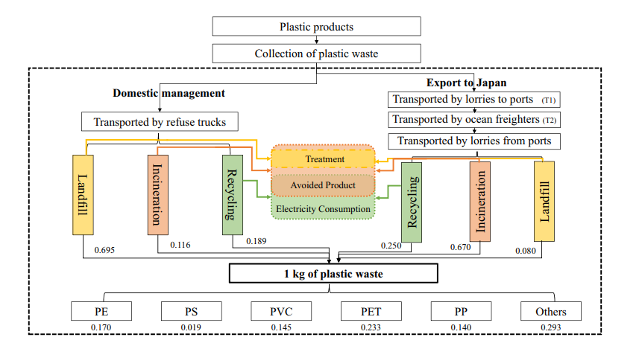

**Fig. 1 System boundaries for LCA of EIT**

**Table 1 Proximate analysis and ultimate analysis of the tannery sludge**

|  |  |  |  |  |  |  |  |  |
| --- | --- | --- | --- | --- | --- | --- | --- | --- |
| Industrial analysis (%) | | | | | Elemental analysis (%) | | | |
| Moisture | Ash | Volatile matter | Fixed carbon | LHV  kJ/kg | C | H | N | S |
| 73.25 | 13.11 | 13.61 | 0.03 | 5346.2 | 16.591 | 2.898 | 2.343 | 0.623 |
| Elemental analysis of heavy metal (mg/kg) | | | Zn | Pb | Cd | Cu | Mn | Cr |
| 380 | 280 | 3 | 70 | 500 | 20490 |

**References**

[1] Zhang, S.; Li, S.; Zhou, W.; Zheng, L. *Chem. Phys.* 2011, 135: 14304.